Coronavirus hit the Migrant Farm Workers
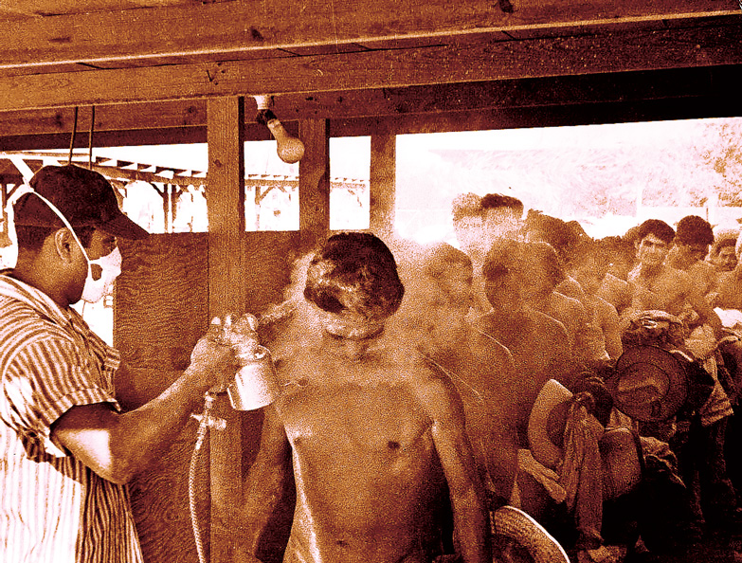

A masked worker fumigates a bracero with DDT at the Hidalgo Processing Center, Texas, while others wait in line. 1956. Photo by Leonard Nadel.

The current pandemic crisis is a real threat to the entire population. We cannot close our eyes to the deaths, contagions, quarantine closures, social distancing, shortages of basic products in the homes, speculation and hoarding of food, school closings, curfews, insufficient response from governments and authorities of health, indifference towards the pressing conditions of the most marginalized people and communities, as well as an increase in precariousness and inequality, is not acceptable. We are mired in a crisis of life that affects us all and it's time to act.

However, there are sectors of the population that are in a more fragile situation, and that are the most affected by the threat of Covid-19 contagion, than all. This sector is made up of unprotected poor migrants who not only do not have access to health programs and medical services due to lack of money or basic health insurance, but can also spread the infection to their families and rural communities because they live in fear and why they don't get treatment or don't seek treatment if they get sick in the United States.

And as if the threat of getting sick and perhaps dying from the coronavirus was not enough, the crisis has also exacerbated the national security system with its impacts of increased police persecution, more authoritarianism, and more militarism against immigrant and border communities. The state, which is supposed to provide security and tranquility to the people, has fostered social divisions and an atmosphere of fear by executing a war strategy to face the current crisis. Instead of an urgent public mobilization to confront the Covid-19 crisis, the state has taken advantage of humanitarian disgrace to exercise more authoritarian control over the population, a greater restriction of human rights, the tightening of anti-migrant policies, a domain rigorously paramilitary cut of the borders and the containment of the free movement of people.

Migrant farm workers have particularly resented this war strategy, as they have to constantly move to and from the border to work and support their families. In the case of El Paso, Texas, the military sector and Customs and Border Protection, with the accompaniment of local and state police, have carried out drills of military security and human containment by force and have closed international bridges completely at least three times in the past few weeks. On such occasions, many migrant farmworkers have been unable to cross to work in the fields, and fears that the border will be closed entirely have taken root.

Hindering the free movement of migrants increases their poverty, since they live daily, if today they do not work, tomorrow they have nothing to feed their families.

On the other hand, the thousands of farmworkers working in the southern New Mexico farming region and El Paso and Hudspeth counties on the Texas side have too low wages that place them even below the Poverty Level set by the same federal government, so they do not have access to medical services or health services. Most do not qualify for low-cost health insurance and rarely go to community clinics, even when they are in very serious condition.

The current militarized environment that is so repressive on the border and the extreme poverty they suffer combine to make them the group most susceptible to the current crisis. So, if they were infected with the coronavirus, they would not seek medical attention and it is very likely that, faced with such a dilemma, they would prefer to return to their land. This creates another additional and even more complex risk. If the worker returns home sick with the coronavirus, it could infect his family and affect his rural community.

Finally, the fear and vulnerability of migrant agricultural workers under this terrible crisis in life is also reflected in a feeling that they are already stigmatized and it would not be too risky to think that, in one of those returns from Mexico, arguing health safety issues, they are among the first to be locked up and quarantined or bathed in chemicals to try to kill off the spread. It happened once, in the middle of the last century, at a dark moment in history, when the braceros who came to work in this country were fumigated for the first time with the carcinogenic chemical DDT so as not to infect the North American population.

The crisis is hitting farmworker migrants very hard. Within this group we include women, children and people suffering from extreme poverty. This group must be at the center of the efforts and the battle to confront the pandemic crisis of the coronavirus. Putting them aside and abandoning them will only exacerbate the real danger that hangs in the head of humanity.

Carlos Marentes
March 13, 2020

